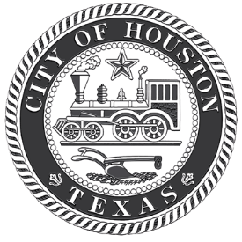
Houston Public Works
CITY OF HOUSTON
Correspondence

Interoffice

To:

Employee Name
Employee Number

From:

Date:

Subject
Supervisor / Manager

64 HOUR RULE

Chapter 14-227 of the Houston Code of Ordinances states that all employees must provide medical documentation for any absences due to illness in excess of 64 hours in order to receive benefits during a benefit year. The benefit year begins September 1 of the current year and ends August 31 of the following year. Receipt of this memo informs you that effective
 | you have exhausted |  | hours of sick leave.
Effective immediately, you must submit original medical documentation for any sick leave
utilized through August 31, | . | Failure to submit proper medical documentation will result
result in docked hours on your paycheck. Additionally, this policy does not release you from the requirement to submit medical documentation each day you call in sick if you are not presently on restrictive leave, nor does it prevent your supervisor from placing you on restrictive leave and recommending disciplinary action for unsatisfactory attendance.

Supervisor

Employee Signature and Employee No. Date

Original: Employee
Copy: Human Resources File

